New results on induced matchings
Martin Charles Golumbic, Moshe Lewenstein
Discrete Applied Mathematics, Vol. 101, pp.157-165 2000
- Introduction

Matching: A matching in a graph is a set of edges no two of which share a common vertex.

Induced Matching: M is an induced matching if no edge connects two edges of M.
2. Polynomial time algorithms for special families of graphs

Split graph: A graph G =(V, E) is defined to be split if there is a partition V = S + K of its vertex set such that S is an independent set and K induces a complete graph. There is no restriction on edges between vertices of S and K.
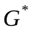: Let G = (V, E) be a graph. The graph G = (E, 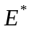) has vertices corresponding to the edges of G with e = (v1, v2) and = (v3, v4), adjacent in G if and only if they are not an induced matching, i.e.,
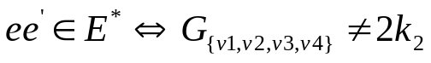
It is easy to see from the definition that the maximum induced matching equal to the maximum independent set in .

Theorem 2.1. (1) If G is an interval graph; then is an interval graph.
(2) If G is a circular arc graph; then is a circular arc graph.
(3) If G is a chordal graph; then is a chordal graph.

3.Trapezoid graphs
Theorem 3.1. If G is a trapezoid graph; then G is a trapezoid graph.

Corollary 3.2. Finding a maximum induced matching in a trapezoid graph can be done in polynomial time.
4. Cocomparability graphs
Interval dimension k: a graph G = (V, E) is said to have interval dimension k if we can assign k interval representations, 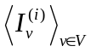, 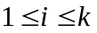,to G, such that (u, v) E (where 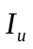 <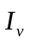 means that interval lies to the left of interval )
Note that trapezoid graphs have interval dimension 2 and thatinterval graphs have interval dimension 1.
The class of cocomparability graphs is exactly the union of class of graphs with interval dimension k(over all k).
Theorem 4.1. If G has interval dimension k, then has interval dimension k.
Corollary 4.2. If G is a cocomparability graph; then Corollary 4.2. If G is a cocomparability graph; then G is a cocomparability graph.
Corollary 4.3. Given a cocomparability graph; in polynomial time we can find a maxmum induced matching. is a cocomparability graph.
5. Interval graphs(linear time)
left-side intersected interval(intersected interval): if there exists u such that (u, v) E and 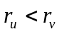.
Left extreme intersected interval(in short the extreme interval): We define an interval 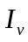 to be the left extreme intersected interval (in short the extreme interval) if is the intersected interval with smallest , i.e. there does not exist a different intersected interval 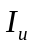 such that .
Left closure we define the left closure of v (relative to a representation) to be {u | 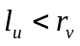}, i.e. all vertices corresponding to the intervals which intersect or are disjoint and to the left of it.
Lemma 5.1. Let G be an interval graph and  its representation. Let v V be a vertex such that is the extreme interval of representation and let 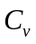 be the left closure of v.
(1) Let M be an induced matching in 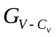 and u a vertex such that (u, v) E and ; then M {(u, v)} is an induced matching of G.
(2) 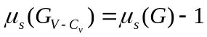.
Algorithm:
1. create an interval representation from the interval graph
2. color every interval green
3. 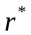← null, M ←null
4. for k = 1 to 2n
(a) case 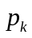 is a left endpoint
i. color I( ) yellow
(b) case ( is a right endpoint) ((v( ),v()) E) ^ (I ( ) not red)
i. add (v( ), v()) to the induced matching M
ii. color every yellow interval red
iii. ← null
(c) case ( is a right endpoint) ((v( ),v()) E) ^ (I ( ) not red)
i. ←
5. return M
end Algorithm
Theorem 5.2. Finding a maximum induced matching on an interval graph can be done in linear time.
6.Tree
Theorem 6.1 (Fricke and Laskar [6]). Determining the size of a maximum induced matching in a tree can be done in linear time.
Created by: Sin-huei Wu
Date: Oct. 15, 2001

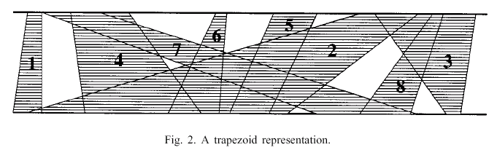
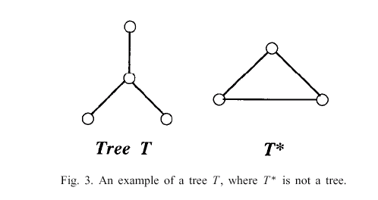
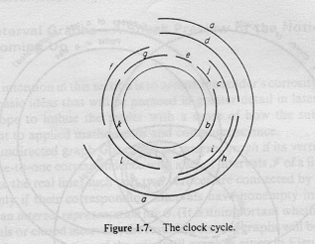

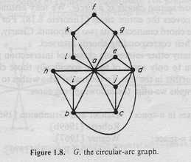
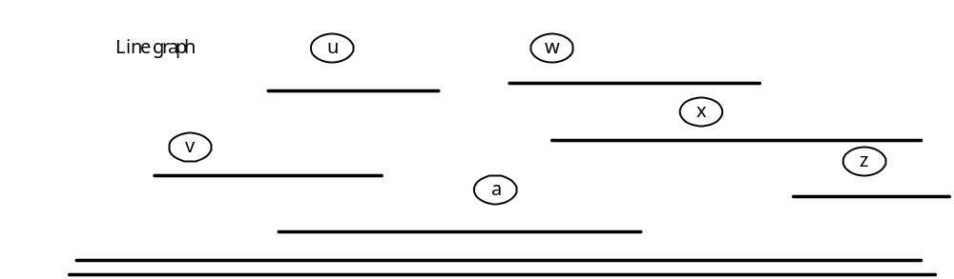
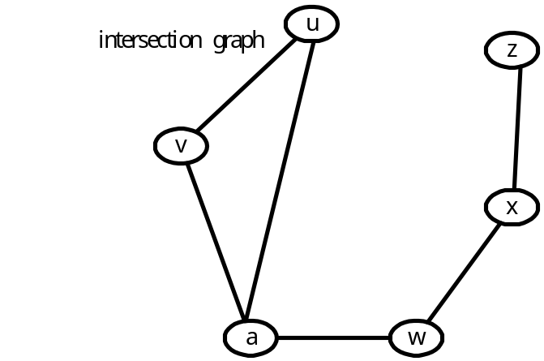
mathching edge set {(u,v),(w,x)}

